ARP Entries – Static

🧱 What Is ARP Entries – Static?
# Source: AI Source: Provided by: [Data Path: Persons Table -> ID Column: 1, Name_En Column: Motasem Essam] -> From: [ChatGPT] on [1/16/2026]
A static ARP entry is a manually configured mapping between an IP address and a MAC address. It is fixed and does not change or expire, even if the device is rebooted or the network changes.

🧠 Simple Definition:
# Source: AI Source: Provided by: [Data Path: Persons Table -> ID Column: 1, Name_En Column: Motasem Essam] -> From: [ChatGPT] on [1/16/2026]
A static ARP entry is a permanent IP-to-MAC mapping manually added to a device's ARP table by an administrator.

📋 Example: Static ARP Entry
# Source: AI Source: Provided by: [Data Path: Persons Table -> ID Column: 1, Name_En Column: Motasem Essam] -> From: [ChatGPT] on [1/16/2026]
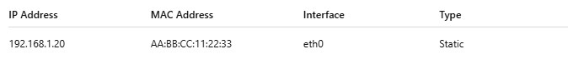
IP Address | MAC Address | Interface | Type
192.168.1.20 | AA:BB:CC:11:22:33 | eth0 | Static

🔧 How to Add Static ARP Entries

▶ On Linux:
# Source: AI Source: Provided by: [Data Path: Persons Table -> ID Column: 1, Name_En Column: Motasem Essam] -> From: [ChatGPT] on [1/16/2026]
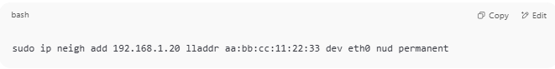
sudo ip neigh add 192.168.1.20 lladdr aa:bb:cc:11:22:33 dev eth0 nud permanent

▶ On Windows:
# Source: AI Source: Provided by: [Data Path: Persons Table -> ID Column: 1, Name_En Column: Motasem Essam] -> From: [ChatGPT] on [1/16/2026]
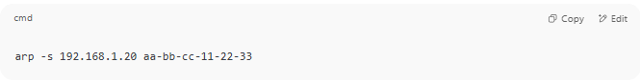
arp -s 192.168.1.20 aa-bb-cc-11-22-33

▶ On Cisco IOS:
# Source: AI Source: Provided by: [Data Path: Persons Table -> ID Column: 1, Name_En Column: Motasem Essam] -> From: [ChatGPT] on [1/16/2026]
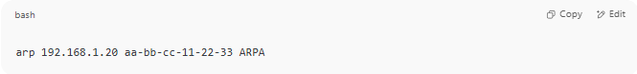
arp 192.168.1.20 aa-bb-cc-11-22-33 ARPA

🛡️ Use Cases for Static ARP
# Source: AI Source: Provided by: [Data Path: Persons Table -> ID Column: 1, Name_En Column: Motasem Essam] -> From: [ChatGPT] on [1/16/2026]
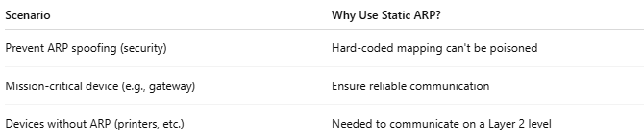

Scenario | Why Use Static ARP?
Prevent ARP spoofing (security) | Hard-coded mapping can't be poisoned
Mission-critical device (e.g., gateway) | Ensure reliable communication
Devices without ARP (printers, etc.) | Needed to communicate on a Layer 2 level

🔍 Key Characteristics of Static ARP
# Source: AI Source: Provided by: [Data Path: Persons Table -> ID Column: 1, Name_En Column: Motasem Essam] -> From: [ChatGPT] on [1/16/2026]
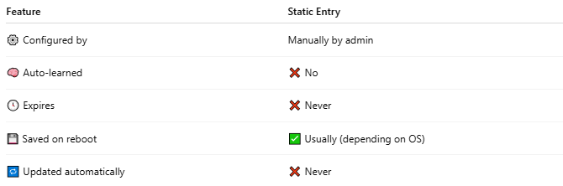

Feature | Static Entry
⚙️ Configured by | Manually by admin
🧠 Auto-learned | ❌ No
🕓 Expires | ❌ Never
💾 Saved on reboot | ✅ Usually (depending on OS)
🔁 Updated automatically | ❌ Never

✅ Summary
# Source: AI Source: Provided by: [Data Path: Persons Table -> ID Column: 1, Name_En Column: Motasem Essam] -> From: [ChatGPT] on [1/16/2026]
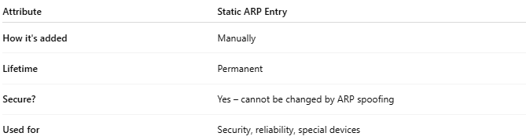

Attribute | Static ARP Entry
How it's added | Manually
Lifetime | Permanent
Secure? | Yes – cannot be changed by ARP spoofing
Used for | Security, reliability, special devices

